In love with Spectera: New in-ear experience for Joy Denalane and Max Herre
Monitor engineer Toni Kern uses Spectera as an IEM system on Max&Joy’s “Alles Liebe” tour

Wedemark, 31 January 2025 – Sound is like love: there are highs and lows. Soul singer Joy Denalane and rapper Max Herre explore their very personal 25-year relationship on their first duet album, ‘Alles Liebe’ (All Love/Lots of love), which they took on tour in November and December 2024. Also on board was their long-time monitor engineer Toni Kern, who used Sennheiser’s Spectera as a monitor system, giving everyone involved an entirely new in-ear monitoring feel.

Toni Kern first encountered a WMAS system around two years ago. Spectera product manager, Bernd Neubauer, had asked his long-time friend if he would carry out a MADI measurement with a prototype system during a production. Kern agreed, and his interest in the new transmission technology was piqued. He visited the Spectera development team to learn more and provide feedback and, at a Sennheiser Sound Experts event, got a taste of what he now calls “a gamechanger, a revolution”: a bidirectional wireless ecosystem that transmits and receives audio and control data on a wideband RF carrier. “Everyone at the event agreed that Spectera takes sound quality to a new level and makes frequency management much easier,” says Kern.

Monitor engineer Toni Kern used the bidirectional Spectera as an IEM system | 

A new in-ear experience for artists and crew
When Kern was approached for Max&Joy’s ‘Alles Liebe’ tour in 2024, he got back to Neubauer to ask if he could take a Spectera system with him. Neubauer was delighted and supplied 26 Spectera SEK bodypacks, three Spectera DAD antennas, and a Spectera Base Station, which provided Denalane, Herre, their band and the backstage crew with a new in-ear experience.

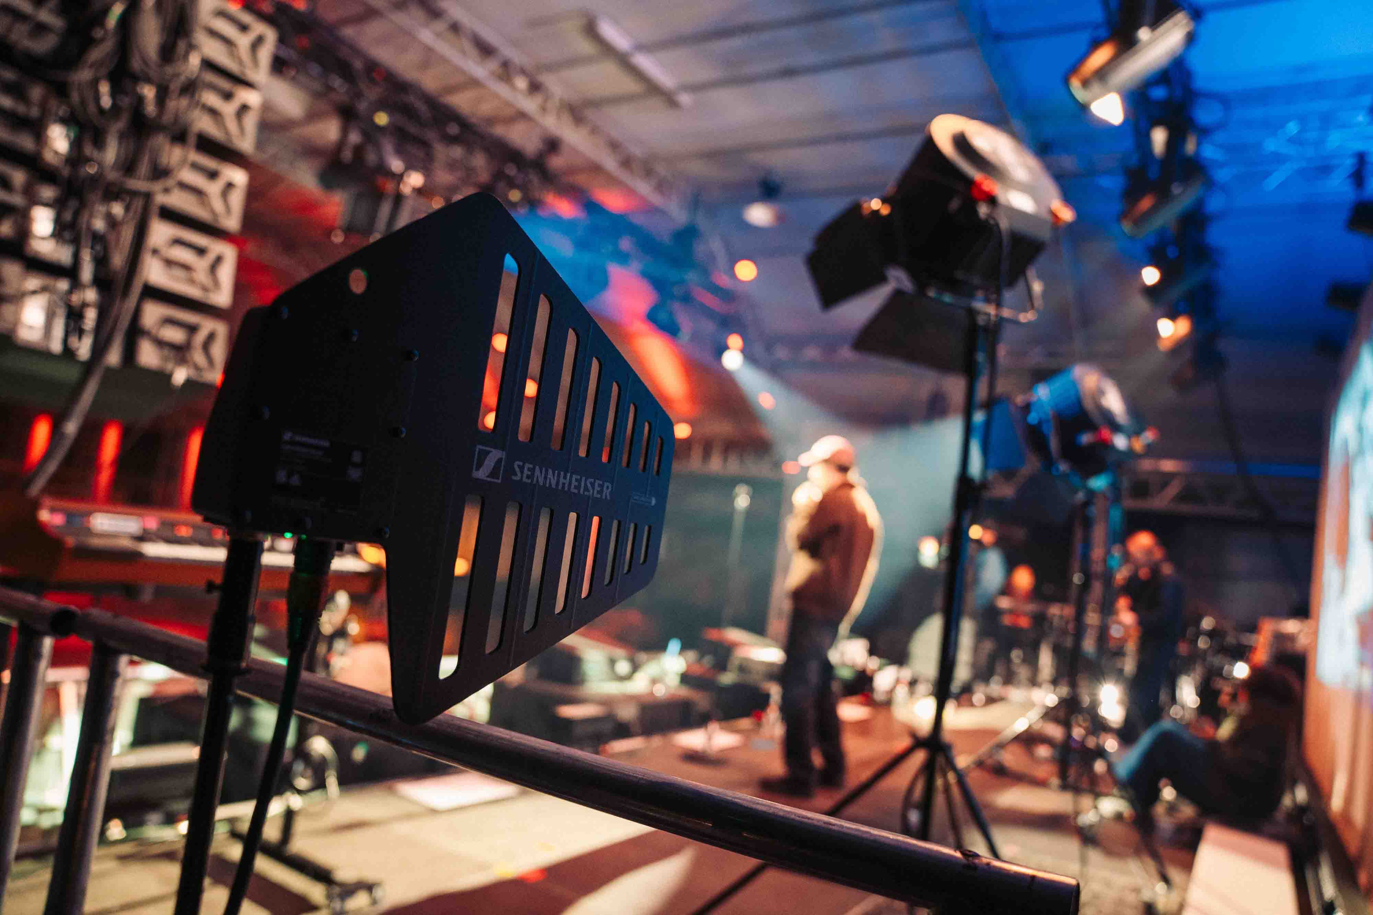 | The DAD transceiving antennas were not only used for audio and control data: Kern reserved an additional DAD for continuous scanning of the RF environment

“I don’t want to just hand the artists devices they don’t know. First, I want to explain the equipment to them technically. Everyone was curious about the new system, tried it out intuitively and was quickly impressed,” says Kern. After a week of rehearsals in Berlin, the tour started. The question remained: Would there be real love under live conditions? And to what extent does Spectera change the workflow for the band and the technical team?

Flexible selection of latency, sound quality and range via audio link modes
“I had between 20 and 24 belt packs in use; in addition to Max and Joy and the musicians, the tour manager, the production manager and guests also received a pack,” Kern explains. “The frequency planning was standard. I scanned the RF environment via a Spectera antenna, and it was no problem at all to find 8 MHz for the wideband system.”

For his 14 IEM stereo mixes, Kern selected the ‘Live’ Stereo Mode from the 11 Spectera Audio Link Modes. This allowed him to provide not only the singers and the band, but also the backstage crew with the best sound and a low latency of just 1.6 milliseconds. “Sound quality is my top priority,” Kern notes. “If it’s not right, we don’t even need to talk about anything else.”

Kern provided Max and Joy, the musicians, and the backstage team with high-quality, low-latency in-ear sound | 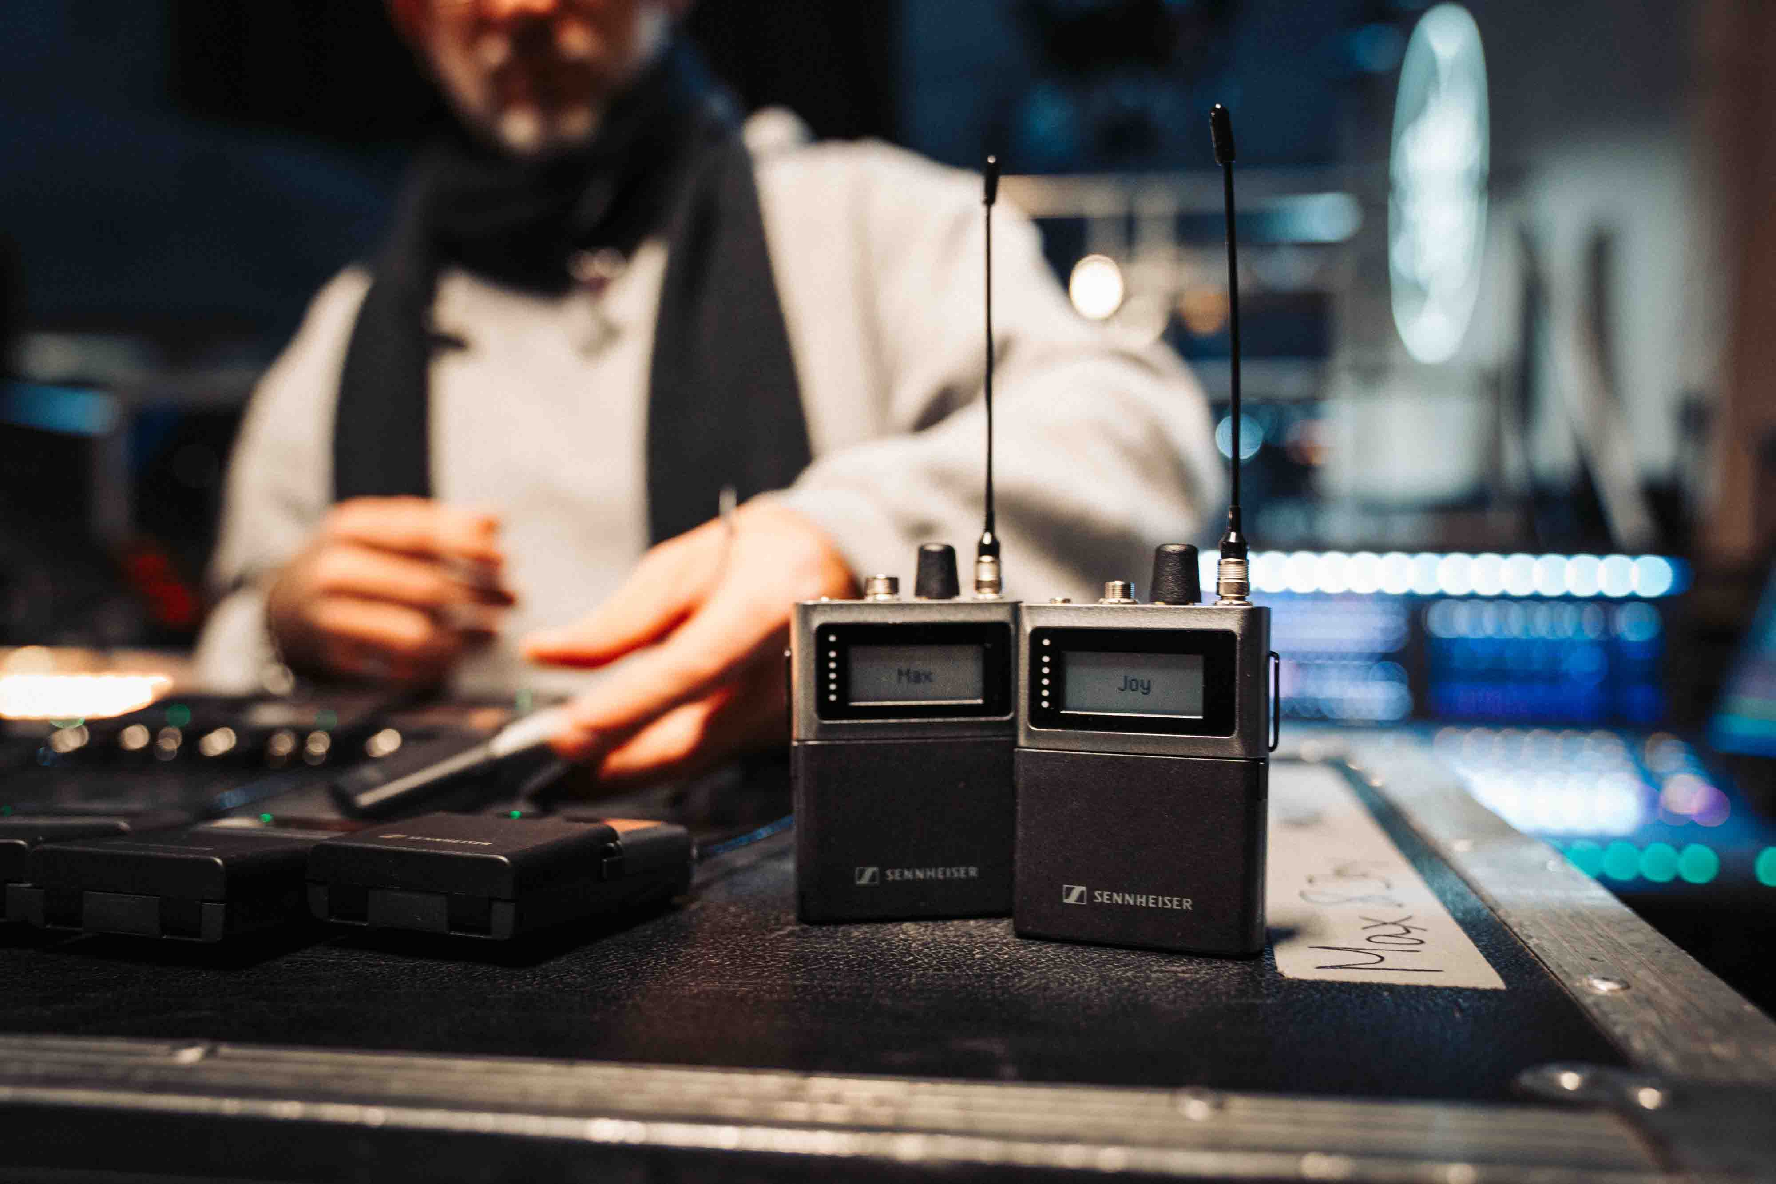

Meanwhile, the audience was treated to gems from the large repertoire that the two exceptional artists Denalane and Herre have created after decades in the music business. In addition to the new duets about quarrelling, making up, and universal values such as solidarity and friendship, the classic ‘Mit dir’ (‘With You’) is, of course, not to be missed – after all, the two fell in love during its production 25 years ago. The joint songs alternate with successful soul tracks from Denalane’s solo projects and Herre’s hip hop grooves from his Freundeskreis days. For these, the band takes a break, and Herre performs together with a DJ. The in-ear sound seems to fit perfectly in all positions and arrangements: “When these top musicians consistently tell me that they are enthusiastic about the Spectera IEM, it carries a lot of weight for me,” says Kern.

It’s a match: Spectera in combination with other equipment
Spectera easily connected with the other equipment in the workflow. “Spectera was phenomenally easy. I connected the MADI output of the 1U Base Station to the engine of the AVID S6L console with a BNC cable – that was it,” says Kern. Two Spectera DAD antennas were added, and a third was reserved specifically for scanning the RF spectrum. Kern also used two L 6000 charging stations to charge the bodypack batteries.

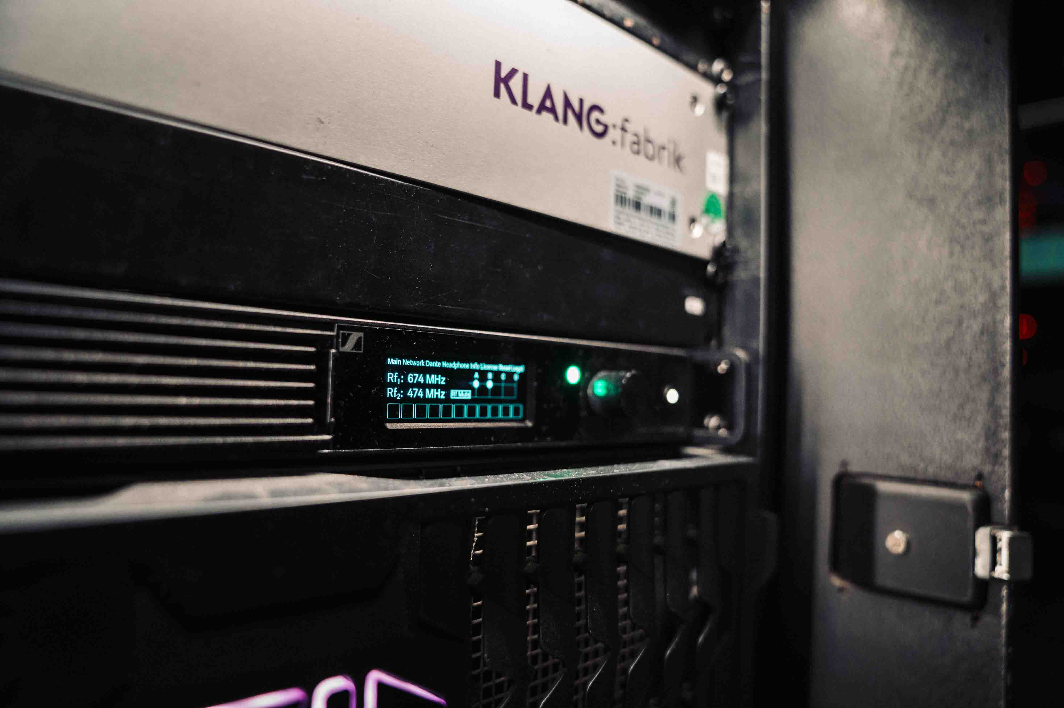 | Instantly ready to use: the 19”, 1 U Spectera Base Station (centre)

“As the Spectera system I was using was still a pre-production model, I had a classic Sennheiser in-ear system with me as a backup, but we didn’t need that at all. We used Spectera at every gig,” says Kern. “Everything worked perfectly together – whether narrowband or wideband, whether Sennheiser or other manufacturers.”

Kern is impressed with both the LinkDesk software and the Base Station’s browser-based control software: “Everything worked quickly, smoothly, and without any problems in terms of channel assignment. I also liked the fact that members of the Sennheiser team came by in person to get feedback from me.”

Real-time monitoring of all bodypacks linked to the Base Station | 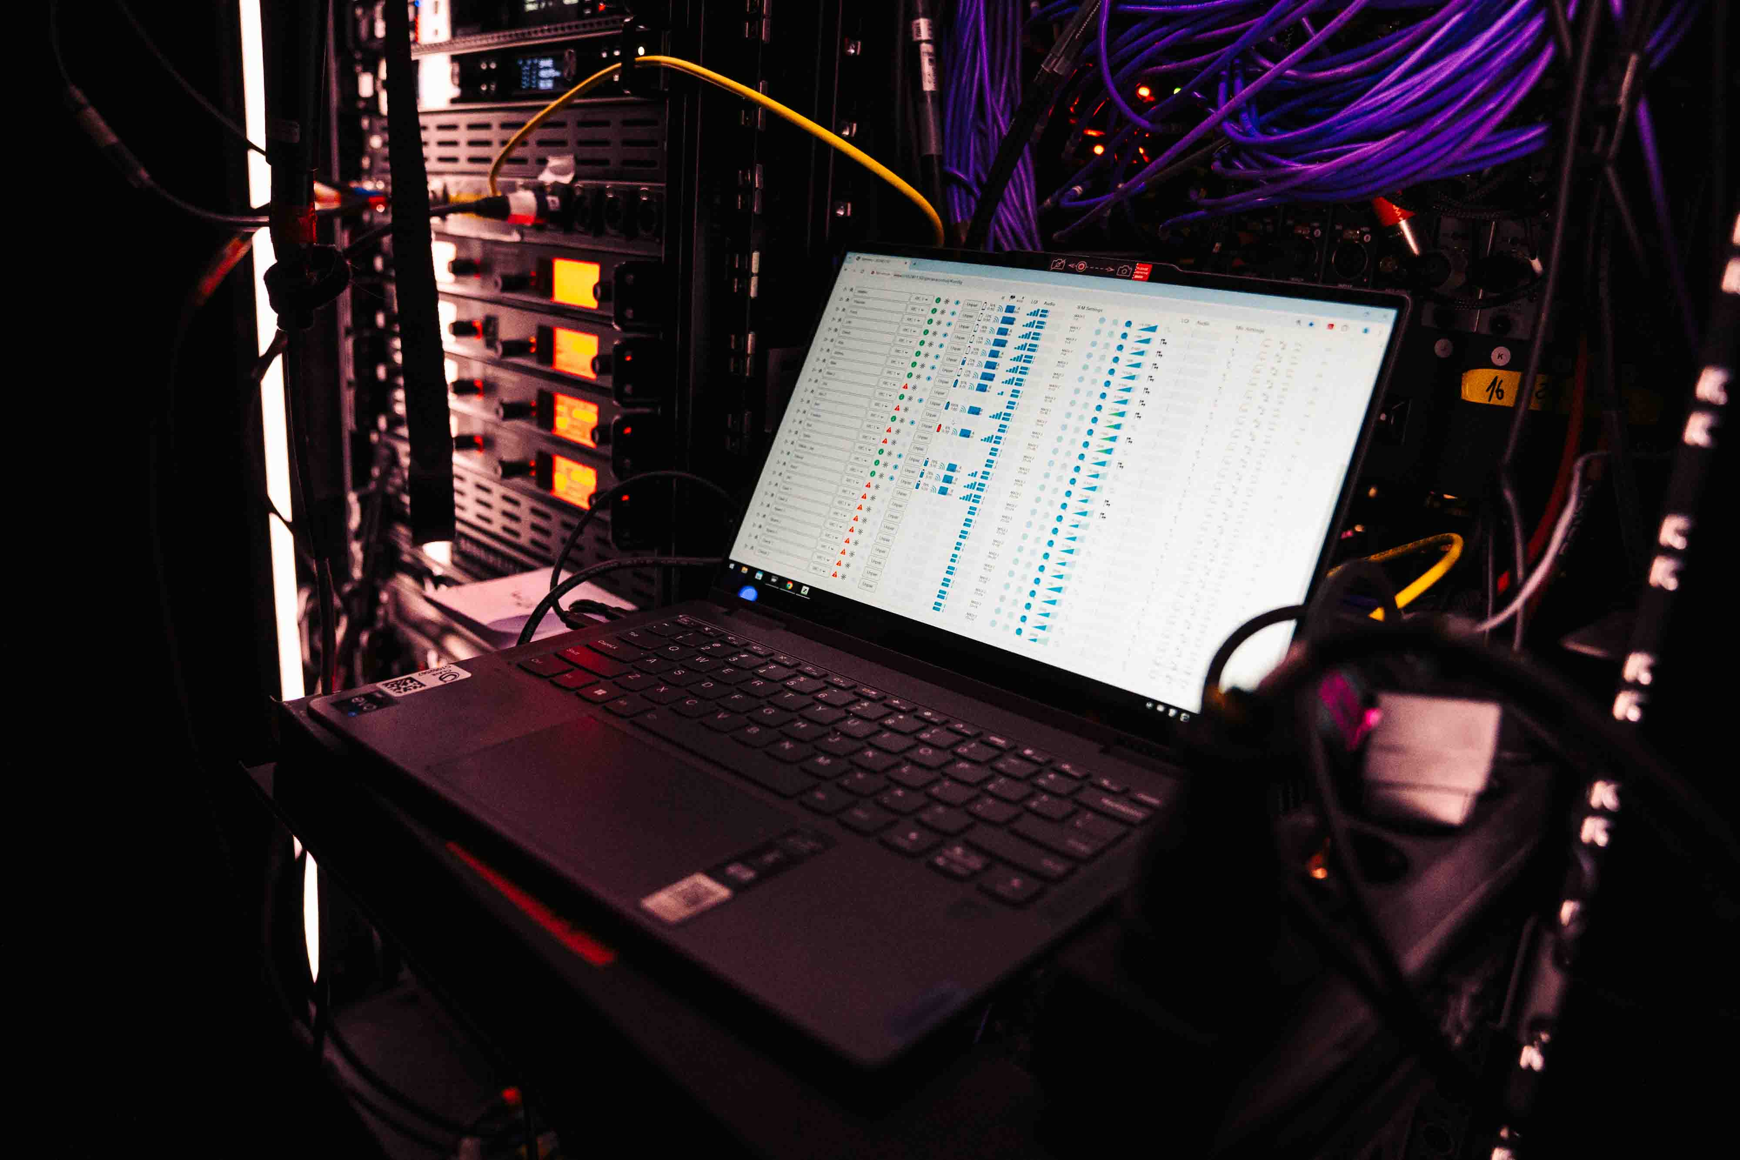

Full confidence: Monitor engineers can correct in-ear volume
Kern describes the ability to read, change and limit the monitoring volume as an ‘incredibly spectacular feature’. “It was unfamiliar to the artists at first, but everyone quickly got used to it, and I could even change a setting during the show without them minding me doing that. As there was a great deal of trust between me as monitor engineer and the artists during this production, it was no problem at all.”

Instead of a volume control with a stop, the Spectera bodypack is equipped with an endless rotary control that ‘remembers’ its setting. In the control software, the volume can be limited to a safe range, thus taking some of the acoustic pressure off the artists.

A ‘spectacular feature’: the monitor engineer can monitor the in-ear volume of the artists and carefully set it to a healthy level | 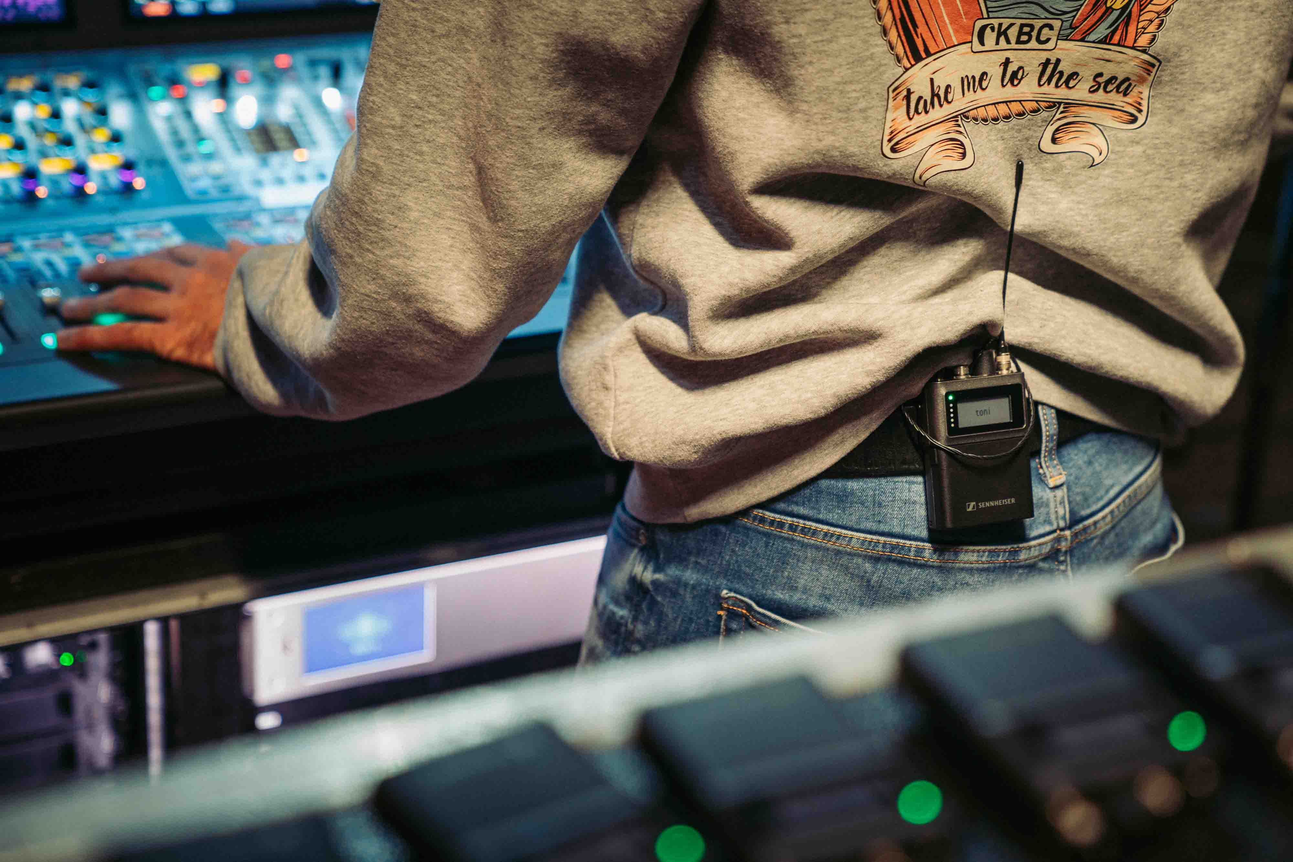

“On stage, the adrenaline rush can quickly lead to extreme settings, and Spectera can produce really high audio levels, but nobody really needs it that loud,” explains Kern. “Now I have the opportunity to gently correct this.”

Kern’s opinion on Spectera is unequivocally positive: “The listening experience, especially for the musicians, is more relaxed over long periods. Your hearing isn’t as stressed, tired and damaged as it might be with other systems, and that has a positive impact on the performance.”

 | ‘Alles Liebe’ continues in 2025, touring open-air venues from June

Max&Joy will also be touring this year: 18 open-air dates for ‘Alles Liebe’ are planned from 3 June 2025.

(Ends)

The high-resolution images accompanying this media release plus additional pictures can be downloaded here.

About the Sennheiser brand
We live and breathe audio. We are driven by the passion to create audio solutions that make a difference. Building the future of audio and bringing remarkable sound experiences to our customers – this is what the Sennheiser brand has represented for more than 75 years. While professional audio solutions such as microphones, meeting solutions, streaming technologies and monitoring systems are part of the business of Sennheiser electronic SE & Co. KG, the business with consumer devices such as headphones, soundbars and speech-enhanced hearables is operated by Sonova Holding AG under the license of Sennheiser.

www.sennheiser.com
www.sennheiser-hearing.com

Global Pro Audio Press Contact
Stephanie Schmidt
stephanie.schmidt@sennheiser.com
+49 (5130) 600 – 1275

